Contact: Maximilien Bianchi FOR IMMEDIATE RELEASE
Cell: 888-555-1212
Email: maximilien.bianchi@gmail.com
AWARD-WINNING FILM PROVIDES SCARES WITHOUT CLICHÉ
Local Filmmakers' Horror Film Selected by Newage Film Festival.

TOPEKA, KS, December 15, 2013 - In the spirit of Rosemary's Baby, local director Max Bianchi's Even the Plants Are Dead masterfully builds suspense in this new eye-popping thriller. The Newage Film Festival in Knowlton, California certainly took notice, naming the short film as an Official Selection of this prestigious West Coast film festival.
Bianchi led a team of 10 local filmmakers to create a 7 minute film that harkens back to the genre-defining horror films of the '60s and '70s, such as Rosemary's Baby. Suspense is masterfully built with foreboding signs that lead to an unexpected ending.
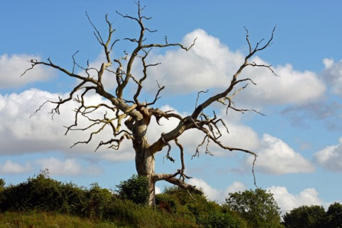
The Newage Film Festival chose the film from hundreds of submissions, and will be screening the film as part of its Scary Film Night on Friday, January 13, 2014.
Bianchi was delighted. "We knew that we had a very controversial film and were hoping for this outcome. This selection by the Newage Film Festival recognizes our team’s suspense-building strategy, and how we brought the story to life."
Even the Plants Are Dead screens at 9 p.m. at the Knowlton Theatre on January 13. Tickets are $10 each and can be purchased either at the door or online at www.knowltontheatres.com.
Even the Plants Are Dead Trailer
- end -
Contact Information. If you'd like more information about this film, or to schedule an interview with the filmmaker, please contact Max Bianchi at 888-555-1212 or by e-mail at maximilien.bianchi@gmail.com
Festival Information. For information about the Newage Film Festival, please contact Festival Director John Doe at 555-333-1212 or contact via email at john.doe @newagefilmfestival.com. The Newage Film Festival is made possible by its sponsors Pepsi and Unilever.

Contact: FILMMAKER NAME FOR IMMEDIATE RELEASE
Cell: (222) 222-2222
Email: FILMMAKER EMAIL ADDRESS
PRESS RELEASE MAIN TITLE IN UPPER CASE - ATTENTION GRABBING
Press Release Sub-Header Gives You the Opportunity to Add Some Meat and Build the Hook for Your Reader Without Reducing the Impact of Main Title.

FILM FESTIVAL LOGO
HERE
FILMMAKER’S CITY, STATE, DATE - Lead paragraph. No selling, just the reasons why this film tells a story or was produced in such a way that it could impact or change somebody’s life. Don’t lose sight of the fact that you need to make this press release interesting for the reader. The lead paragraph introduces the “who, what, when, where and how” of your story and must immediately draw the reader into the story.
Body. Now the rest of the press release should provide the back-up to the claims in the headline and lead paragraphs. Do not forget to link to the film festival’s web-site from this text.
Placeholder for your attention-grabbing image. Link image and caption to your trailer, if you have one. In any case, use an image to capture interest. Do not make your film available in this press release

You may want to include a quote from a member of your production team, or from an expert, that puts the information in perspective and helps it sizzle.
Write the material from a journalist’s perspective, omitting the use of the words “I”, “you” and “me”, unless these words are part of a quote.
Caption Linked to Your Trailer

You can go to two pages, but no more than 400 words in the document. Proof-read carefully!
If you would like us to check your press release, just email it to pr-service@youngcuts.com
- end -
(“- end -“ tells the journalist that the press release’s content ends)
Contact Information. If you'd like more information about this film, or to schedule an interview with the filmmaker, please call FILMMAKER NAME at (222) 222-2222 or e-mail FILMMAKER EMAIL ADDRESS
Festival Information. Insert Festival Information from email here. This should include a contact name, phone number, e-mail address and festival website address.

